


Complete Ergonomics Injury Prevention Solutions

Ergonomics

Wellness

Software

Customized Programs Built around your needs

- Practical Solutions to facilitate employee health, safety and productivity.
- Innovative ways to automate your program to save you time and money
- The Human-Touch: Personal consultants interact with you to determine the
best fit for your company and employees.
- National and International Support: Elysian Integrated Health Solutions (EiHS) has a network of certified experts in the field that are committed to your success.

Mission Statement

The mission of Elysian Integrated Health Solutions is to implement the best team of ergonomics, safety and healthcare professionals to provide optimal care to employees. At EiHS, our success depends on offering a complete range of customized injury prevention and wellness services including Ergonomic Consulting, Postural Re-training and Safety.

About the Company

EiHS provides a full range of injury prevention, safety and ergonomics management solutions. We made the connection and saw that if we provided integrated Safety and Wellness solutions with ergonomics process improvement, an employee is less likely to get injured on the job. Our professional consultants will sit down with you to determine what services would be best for your company. In addition, we can demonstrate a detailed cost savings analysis to show how your company can receive the most benefits from one or all of our services. Our results speak volumes, as we have achieved as much as a 65% reduction in the ergonomic injury rate within two years.

Benefits of Wellness and Safety Services

- Cost Savings (through lost work time, hiring temporary staff, decreased Worker’s Compensation Costs and lower insurance premiums)

- Reduction of injury rate

- Increase Employee retention

- Increase Employee productivity

- CAL OSHA compliance through Workstation Evaluations, Training, and Online tracking of Repetitive Motion Injuries

Ergonomic Services

Comprehensive Ergonomics Program Management with software
Industrial and Office Workstation Assessments
Worker’s Compensation/Legal Cases
OSHA Compliance
“Ergonomic Awareness” Training
Supervisor Training
Ergonomic Lab Development
Ergonomic Product Development
Functional Capacity Evaluations
ADA Compliance
Six Sigma and Lean Integration with ergonomic principles

Wellness
Personal Training
On-site exercise classes
Yoga instruction
Individual and Group instruction
On-site Massage

Principal Profile

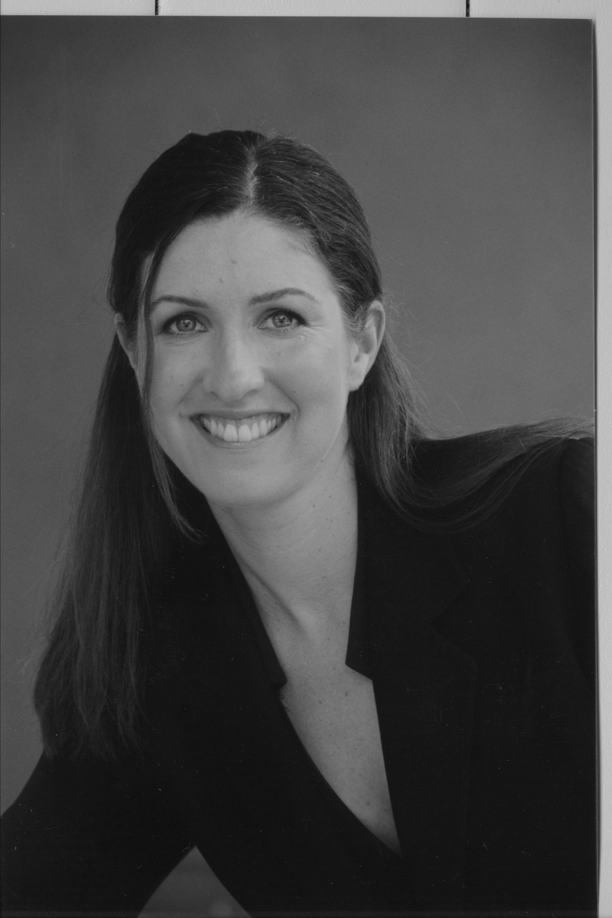

Charissa Shaw, the Chief Executive Officer and President of Elysian Integrated Health Solutions, is a certified Occupational Therapist, practicing Ergonomist and Certified Fitness Trainer. Ms. Shaw attended the # 1 graduate program in the nation for Occupational Therapy, the University of Southern California (USC). After she received her Masters from USC, she began working as an Environmental Health and Safety Specialist for the University of California, Los Angeles (UCLA). While at UCLA, Ms. Shaw gained experience in Office and Industrial Ergonomics as well as received frequent exposure to Cumulative Trauma Disorders working under the Department of Industrial Hygiene. In addition to attending numerous conferences, Ms. Shaw received her certificate in “Applied Office Ergonomics” in November 2000 through Humantech. In January 2001, Ms. Shaw began working as a Senior Ergonomic Consultant and Project Manager for AOL Time Warner, Bank of America, Union Bank of California, Brio Technology, Coldwell Banker, Appgenesys and Transamerica Insurance and Investments Group. As an Environmental Health and Safety Consultant for AOL, Ms. Shaw facilitated the development of a “Crisis Management Team” and an “Emergency Response Team”. In the field of ergonomics, past client experience includes Carlson Companies, Carlson Wagonlit Travel, Qualcomm, CTG Energetics, Google, Cisco Systems, Inovis, City of San Gabriel, City of Buena Park, Great American Custom, ACM Central, Miller, Brown & Dannis, Nestle, City of Hope, Square Enix, New York Times, Newsday, Allsteel, Hebrew Homes, Foley & Lardner, Los Angeles County, Colen and Lee, YMCA, Los Angeles Police Department, Impact General, Foley and Lardner, Electronic Arts, Google, Symantec, Cisco, Orange County Transportation Authority and Ameron International. In addition to speaking internationally on ergonomics, Ms. Shaw has been speaker at the National Applied Ergonomics Conference, Eastern Ergonomics Conference and Exposition and National Ergonomics Conference in Las Vegas. Her international experience includes Malaysia and India, speaking on Office Ergonomics. Previously, she was an Adjunct Professor of Ergonomics in the department Occupational Science and Therapy at USC. Having been trained as a Six Sigma Specialist, Ms. Shaw integrates Six Sigma and Lean principles into the ergonomics process.
Phone: (310) 379-1906
Email: info@elysianhealth.com

